About Belarusian State University

The Belarusian State University (BSU) is a leading scientific, educational, innovation and cultural center of the Republic of Belarus. It was founded on October 30, 1921. Today at the BSU near 7400 employees carry out their duties and 2500 of them occupy full-time teaching positions within university's major faculties and institutes. The BSU teaching staff includes 15 academicians and 16 Corresponding Members of the National Academy of Science of Belarus, 400 Doctors of Science and 1840 PhD degree holders. The BSU students’ community consists of more than 30,000 undergraduate and graduate students, postgraduate and postdoctoral students. More than 1700 international students from 53 countries of world are pursuing their education at the BSU.
The entire complex of the BSU includes 16 faculties and 6 educational institutes, 10 educational establishments, 10 research and development institutes and centers, 41 research and developments laboratories, 10 innovation and production enterprises. According to major international rankings the BSU is among 2 per cent of world leading universities out of 30 thousand educational institutions. Annually more than 1000 various scientific publications and more than 5000 articles are publishes, more than 100 scientific and practical conferences are held.
Among BSU alumni is a Nobel Prize winner, several prominent scientists, educationalists and political leaders working in many countries of the world.

About United Institute of Informatics Problems

United Institute of Informatics Problems of the National Academy of Sciences of Belarus is the leading organization in Belarus in fundamental and applied research on information technologies: CAD/CAM/CAE systems, applied mathematics, high performance parallel computing, bioinformatics and medical informatics, geoinformation systems, digital cartogragraphic systems, Space informatics, GRID-technologies. The Institute is the provider of scientific and educational Internet networks in Belarus. It takes part in state recommendations on information technologies implementation, scientific support of informatization processes, prognosis in related science and technology fields in Belarus, high skill specialists training.
The staff of the institute is about 390 persons including 148 research workers: 1 Corresponding Member of the National Academy of Science of Belarus, 15 Doctors of Science and 68 – with PhD degree.

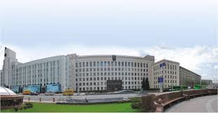
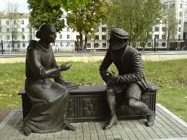
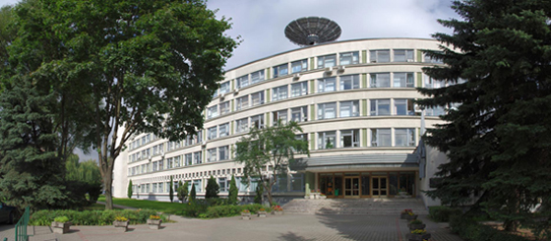

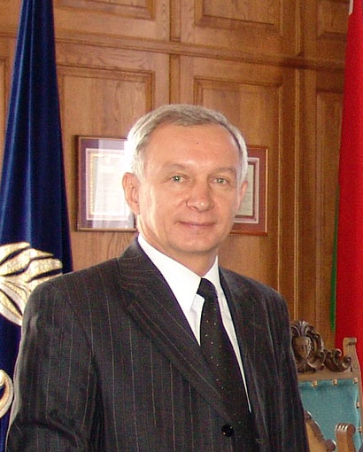
Rector’s Welcome Message
I am pleased to welcome you at the Belarusian State University, a leading national university in the Republic of Belarus. The BSU is a big educational, scientific and production institution that has a high position in the world. For example, according to QS international ranking in 2015 BSU is among 430 best world universities. The BSU is the only Belarusian university in the list of the prestigious Times Higher Education World University Rankings.
Our university aims at providing students with the best methods and the latest technologies of knowledge acquisition. There are 16 Faculties, 6 Educational institutes and 10 Educational establishments which provide training on undergraduate and post-graduate levels of education. We offer a variety of educational programs at all levels of education. The Higher Education Program is organized at the BSU major Faculties and Educational Institutes through 56 specialties and more than 250 specializations. Training along the Master’s Degree Program is conducted through 48 specialties. The PhD Program which is aimed to prepare highly qualified researchers holding a candidate of science (Ph.D.) degree is provided through 142 specialties of different branches of science. In order to equip international students with the Russian Language and learning strategies and skills which enable them to study professional disciplines and be admitted to a degree programs the BSU provides pre-university education program.
The maintenance of research excellence has been a very high priority and all our courses benefit from being taught in an active research environment. Today the BSU includes 10 research and development institutes and centers, 41 research and developments laboratories, 10 innovation and production enterprises. Annually more than 1000 various scientific publications and more than 5000 articles are publishes, more than 100 scientific and practical conferences are held. Belarusian State University is one of the leading universities at the market of development projects. Currently, the university holds 297 assignments (tasks) on 12 state programs of research. BSU is a leading organization and executor in 8 programs.
Our university belongs to a highly internationalized university community and puts a great attention to cooperation with foreign partners both at inter-university level and within international projects framework. About 2500 foreign students study at BSU every year. 25-30 international projects focused on academic exchanges, modernization of university management, design of joint study programs, development of infrastructure, organization of conferences, seminars and other events within such programs as Tempus, Erasmus Mundus, Jean Monnet, EU Cross-Border Cooperation, DAAD, FPB-Belarus, SIDA, VISBY, Baltic University, CIMO, Visegrad Fund, CEI Fund, Eurasia, UNICEF, UNESCO and many others are implemented at BSU annually.
Academic mobility takes particular importance in the modern world today and is the main component of the inter-university cooperation. More than 1500 teachers, young scientists, undergraduates, master students and postgraduate students of the Belarusian State University travel abroad every year to undergo scientific training, deliver lectures, participate in conferences, as well as to do research and make joint international projects.
As a conclusion, I hope that the discussions and exchanges of ideas at the Symposium held in our university will be valuable for all participants. I wish you successful work and all the very best.

Sergey V. Ablameyko, Academician, Rector, Belarusian State University

Message from the General Chairs

 | 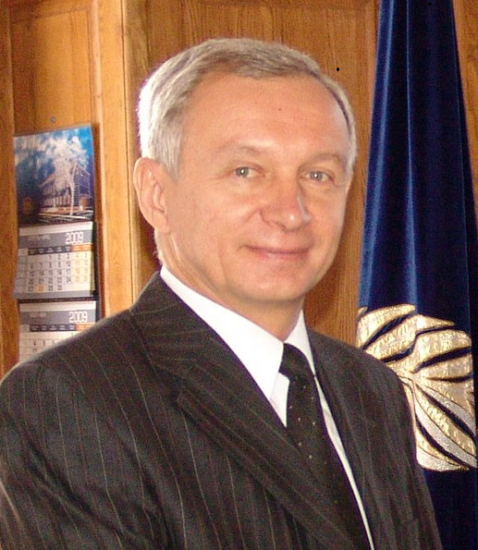 | 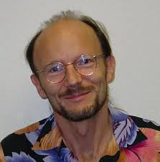 | 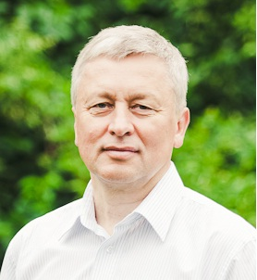
We are delighted to welcome you to the 12th International Symposium on Bioinformatics Research and Applications (ISBRA 2016) being held on the campus of Belarusian State University in historic city of Minsk. We are honored to serve the international community by bringing together scholars, scientists and students from academia, laboratories, and industry to this premier meeting.

We would like to thank Program Chairs Anu Bourgeois, Pavel Skums, Xiang Wan and Alex Zelikovsky for putting together a terrific technical program. We thank the program committee and reviewers for their hard work, and also thank all authors who submitted papers and abstracts for their contributions. We believe that you will enjoy all contributed and keynote talks this week!

We are grateful to the Local Organizing Chair Dmitry G. Medvedev and also Yury M. Metelsky for help in coordinating ISBRA 2016. We thank the Finance Chairs Yury Metelsky and Alex Zelikovsky for their outstanding job in managing the bank account and registration system. We also thank the Publicity Chair Erin-Elizabeth A. Durham for her assistance in publicizing the symposium. Finally, we thank the Publications Chair Igor E. Tom for his efforts.

We would like to recognize Belarusian State University for hosting ISBRA 2016. Last but not least, we would like to thank our sponsors: the National Science Foundation, Belarusian State University and United Institute of Informatics Problems of National Academy of Sciences of Belarus. Thanks to their generous support we have been able to award travel fellowships to several graduate students and post-doctoral scholars from different countries of the world.

We hope you will have a wonderful time at the symposium and enjoy Belarus - the beautiful country in the heart of Europe

Sergei V. Ablameyko, Belarusian State University
Bernard Moret, École Polytechnique Fédérale de Lausanne
Alexander V. Tuzikov, United Institute of Informatics Problems

Message from the Program Chairs

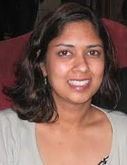 |  | 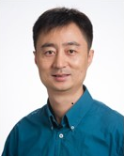 | 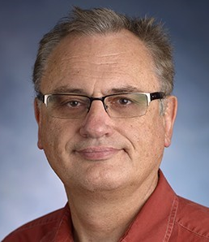

On behalf of the Program Committee, we would like to welcome you to the he 12th edition of the International Symposium on Bioinformatics Research and Applications (ISBRA 2016), held on June 5-8, 2016 at the Belarusian State University in Minsk, Belarus. The symposium provides a forum for the exchange of ideas and results among researchers, developers, and practitioners working on all aspects of bioinformatics and computational biology and their applications.
This year we received 77 submissions in response to the call for extended abstracts. The Program Committee decided to accept 42 of them for publication in the proceedings and oral presentation at the symposium. We have also received 23 submissions in response to the call for short abstracts. The technical program features invited keynote talks by five distinguished speakers. Dr. Teresa M. Przytycka from National Institutes of Health will speak on network perspective on genetic variations: from model organisms to diseases, Prof. Ion Mandoiu from University of Connecticut will speak on challenges and opportunities in single cell genomics, Prof. Alexander Schoenhuth from Centrum Wiskunde and Informatica will speak on dealing with uncertainties in big genome data, Prof. Ilya Vakser from University of Kansas will speak on genome-wide structural modeling of protein-protein interactions and Prof. Max Alekseyev from George Washington University will speak on multi-genome scaffold co-assembly based on the analysis of gene orders and genomic repeats.
We would like to thank the Program Committee members and external reviewers for volunteering their time to review and discuss symposium papers. We would like to extend special thanks to the Steering and General Chairs of the symposium for their leadership, and to the Finance, Publicity, Workshops, Local Organization, and Publications Chairs for their hard work in making ISBRA 2016 a successful event. Last but not least we would like to thank all authors for presenting their work at the symposium.

Anu Bourgeois, Georgia State University
Pavel Skums, Centers for Disease Control and Prevention
Xiang Wan, Hong Kong Baptist University
Alex Zelikovsky, Georgia State University

Keynote Speakers
Teresa M. Przytycka
Senior Investigator
Computational Biology Branch,
The National Center for Biotechnology Information
National Institutes of Health

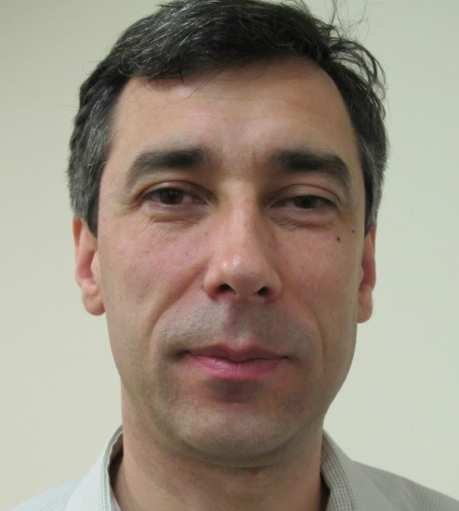 |  |  | Ion Mandoiu  Professor  Computer Science and Engineering Department  University of Connecticut
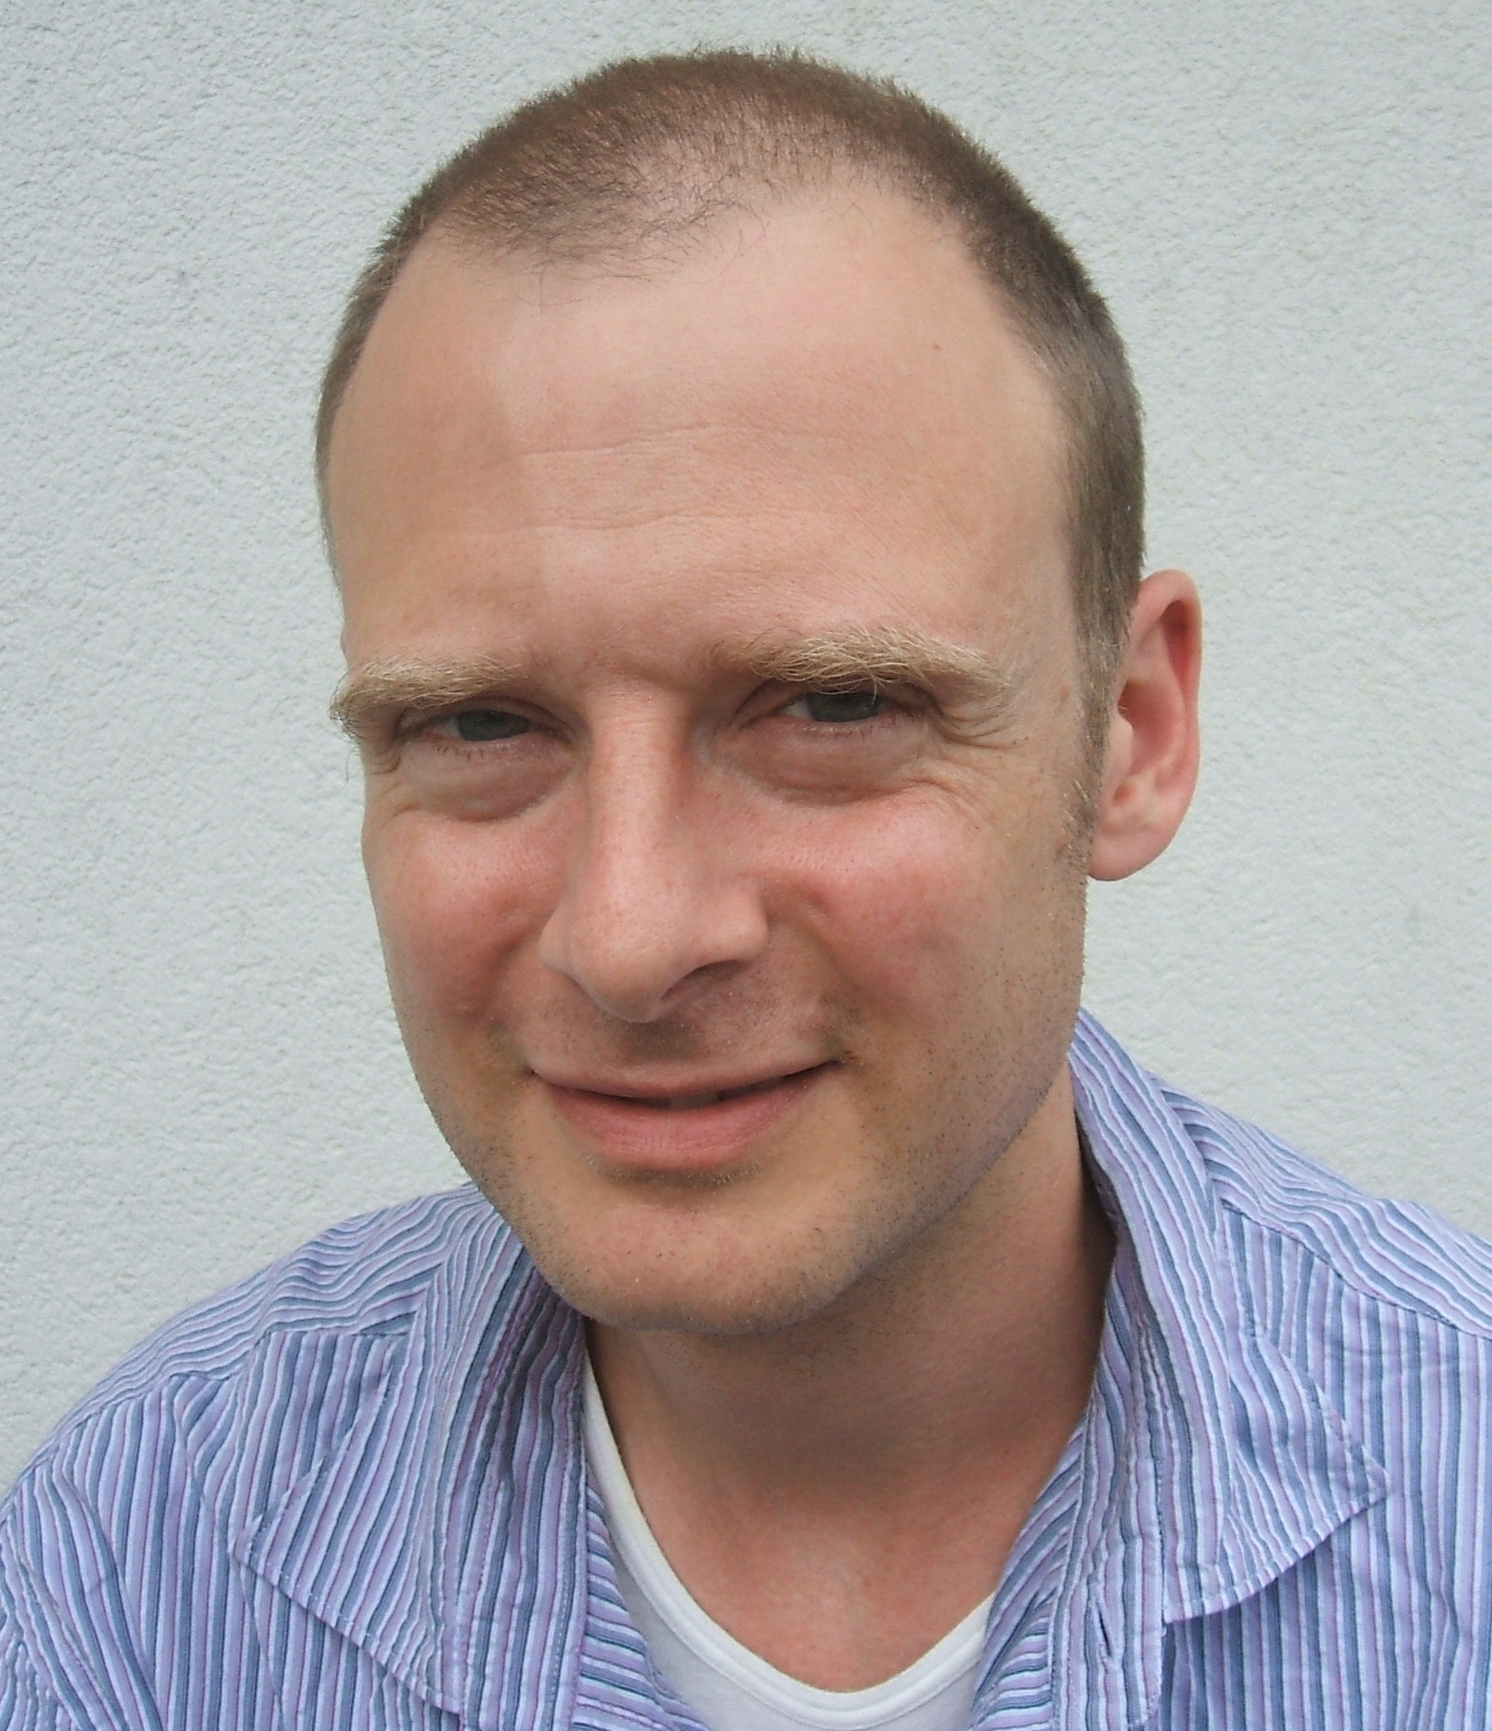 |  |  | Alexander Schoenhuth  Senior Researcher  Computational Genomics Research Group  Centrum Wiskunde and Informatica
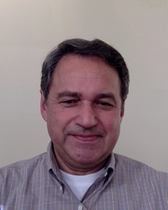 |  |  | Ilya Vakser  Professor and Director,  Center for Computational Biology  University of Kansas
Max Alekseyev
Associate Professor
Department of Mathematics and Computational Biology Institute
George Washington University

Symposium Organizers

Steering Committee

Dan Gusfield (UC Davis)

Ion Mandoiu (UConn)

Yi Pan (GSU), Chair

Marie-France Sagot (INRIA)

Ying Xu (UGA)

Alexander Zelikovsky (GSU)

General Chairs

Sergei V. Ablameyko (BSU)

Bernard Moret (EPFL)

Alexander V. Tuzikov (UIIP)

Program Chairs

Anu Bourgeois (GSU)

Pavel Skums (CDC)

Xiang Wan (HKBU)

Alex Zelikovsky (GSU)

Finance Chairs

Yury M. Metelsky (BSU)

Alex Zelikovsky (GSU)

Publications Chair

Igor E.Tom (UIIP)

Local Organization Chair

Dmitry G. Medvedev (BSU)

Publicity Chair
Erin-Elizabeth A. Durham (GSU)

Webmaster

Igor Mandric (GSU)

Committee Members

Kamal Al Nasr (Tennessee State University)  Sahar Al Seesi (University of Connecticut)  Max Alekseyev (George Washington University)  Mukul S. Bansal (University of Connecticut)  Robert Beiko (Dalhousie University)  Paola Bonizzoni (Universita di Milano-Bicocca)  Anu Bourgeois (Georgia State University)  Zhipeng Cai (Georgia State University)  D. S. Campo Rendon (Centers for Disease Control and Prevention)  Doina Caragea (Kansas State University)  Tien-Hao Chang (National Cheng Kung University)  Ovidiu Daescu (University of Texas at Dallas)  Amitava Datta (University of Western Australia)  Jorge Duitama (International Center for Tropical Agriculture)  Oliver Eulenstein (Iowa State University)  Lin Gao (Xidian University)  Lesley Greene (Old Dominion University)  Katia Guimaraes (Universidade Federal de Pernambuco)  Jiong Guo (Universitaet des Saarlandes)  Jieyue He (Southeast University)  Jing He (Old Dominion University)  Zengyou He (Hong Kong University of Science and Technology) | Steffen Heber (North Carolina State University)  Jinling Huang (East Carolina University)  Ming-Yang Kao (Northwestern University)  Yury Khudyakov Centers for Disease Control and Prevention)  Wooyoung Kim (University of Washington Bothell)  Danny Krizanc (Wesleyan University)  Yaohang Li (Old Dominion University)  Min Li (Central South University)  Jing Li (Case Western Reserve University)  Shuai Cheng Li (City University of Hong Kong)  Ion Mandoiu (University of Connecticut)  Fenglou Mao (University of Georgia)  Osamu Maruyama (Kyushu University)  Giri Narasimhan (Florida International University)  Bogdan Pasaniuc (University of California at Los Angeles)  Steven Pascal (Old Dominion University)  Andrei Paun (University of Bucharest)  Nadia Pisanti (Universita di Pisa)  Russell Schwartz (Carnegie Mellon University)  Joao Setubal (University of Sao Paulo)  Xinghua Shi (University of North Carolina at Charlotte)  Yi Shi (Jiao Tong University)  Pavel Skums (Centers for Disease Control and Prevention)  Ileana Streinu (Smith College)  Zhengchang Su (University of North Carolina at Charlotte) |  |  | Wing-Kin Sung (National University of Singapore)  Sing-Hoi Sze (Texas A&M University)  Weitian Tong (Georgia Southern University)  Gabriel Valiente (Technical University of Catalonia)  Xiang Wan (Hong Kong Baptist University)  Jianxin Wang (Central South University)  Li-San Wang (University of Pennsylvania)  Peng Wang (Shanghai Advanced Research Institute)  Lusheng Wang (City University of Hong Kong)  Seth Weinberg (Old Dominion University)  Fangxiang Wu (University of Saskatchewan)  Yufeng Wu (University of Connecticut)  Minzhu Xie (Hunan Normal University)  Dechang Xu (Harbin Institute of Technology)  Can Yang (Hong Kong Baptist University)  Ashraf Yaseen (Texas A&M University-Kingsville)  Guoxian Yu (Southwest University)  Alex Zelikovsky (Georgia State University)  Yanqing Zhang (Georgia State University)  Fa Zhang (Institute of Computing Technology)  Leming Zhou (University of Pittsburgh)  Fengfeng Zhou (Chinese Academy of Sciences)  Quan Zou (Xiamen University)

Sponsors

Belarusian State University

United Institute of Informatics Problems

National Science Foundation

Georgia State University

ISBRA 2016 Program

Sunday, June 5, 2016
Café “Mensk”, vulica Savieckaja 9 (ул. Советская, 9)
5:00pm-  8:00pm | Registration and Reception | Café “Mensk”, vulica Savieckaja 9
Monday, June 6, 2016
Belarusian State University
7:30am-  8:10am | Registration | Rectorate Building

8:10am-  8:30am | Welcome Remarks  Prof. Dr. Sergey V. Ablameyko | Great Hall of Rectorate Building

8:30am-  9:30am | Plenary Session  Chair: Alex Zelikovsky |  | Great Hall of Rectorate Building
Keynote talk
Network perspective on genetic variations: from model organisms to diseases
Teresa M. Przytycka, National Institutes of Health
9:30am-  9:50am |  | Coffee Break

9:50am-  11:55am |  | Parallel Sessions 1
Session 1A:  Room: Great Hall of Rectorate Building  Chair: Max Alekseyev | Session 1B:  Room: Physics Faculty Building, Lecture Hall 213  Chair: Teresa M. Przytycka
Sensitive detection of low frequency single nucleotides variants from amplicon and capture sequencing data with Leucippus, Nikolaos Vasmatzis, Chen Wang, Sarah Kerr, Jamie Bakkum-Gamez, Flora Vaccarino and Alexej Abyzov | Consistent visualization of multiple rigid domain decompositions of proteins, Emily Flynn and Ileana Streinu
MegaGTA: a sensitive and accurate metagenomic Gene-Targeted Assembler using iterative de Bruijn graphs, Dinghua Li, Yukun Huang, Chi-Ming Leung, Ruibang Luo, Hing-Fung Ting and Tak-Wah Lam | SkipCPP-Pred: Promising Prediction Method for Cell-Penetrating Peptides Using Adaptive k-skip-n-gram Features on a High-quality Dataset, Wei Leyi and Zou Quan
HapIso : An Accurate Method for the Haplotype-Specific Isoforms Reconstruction from Long Single-Molecule Reads, Serghei Mangul, Harry Yang, Farhad Hormozdiari, Elizabeth Tseng, Alex Zelikovsky and Eleazar Eskin. | HIGHLIGHT: Modeling of Protein Inner-Conformation Dynamics by Solving Mass Transportation Problem, Sergey Knyazev, Gaik Tamazian, Eugene Stepanov and Yuri Porozov
De Novo Assembly of Mitochondrial Genomes from Low Coverage Whole-Genome Sequencing Reads, Fahad Alqahtani and Ion Mandoiu | A functional ontology-based score for template-based protein docking, Anna Hadarovich, Ivan Anishchenko, Petras Kundrotas, Ilya Vakser and Alexander Tuzikov.
Filling a protein scaffold with a reference, Letu Qingge, Xiaowen Liu, Farong Zhong and Binhai Zhu | CPredictor2.0: Effectively Detecting Both Small and Large Complexes from Protein-Protein Interaction Network, Bin Xu, Jihong Guan, Yang Wang and Shuigeng Zhou

12:00pm-  1:30pm |  |  | Lunch |  |  | Cafeteria of Rectorate Building
1:30pm-  2:30pm |  |  | Plenary Session  Chair: Alexander Tuzikov |  | Great Hall of Rectorate Building
Keynote talk
Genome-wide structural modeling of protein-protein interactions
Ilya Vakser, University of Kansas
2:30pm-  2:50pm | Coffee Break

2:50pm-  4:05pm | Parallel Sessions 2
Session 2A:  Room: Great Hall of Rectorate Building  Chair: Ion Mandoiu | Session 2B:  Room: Physics Faculty Building, Lecture Hall 213  Chair: Ilya Vakser
An improved burden-test pipeline for cancer sequencing data, Yu Geng, Zhongmeng Zhao, Xuanping Zhang, Wenke Wang, Xiao Xiao and Jiayin Wang | NEMo: An Evolutionary Model with Modularity for PPI Networks, Min Ye, Gabriela Racz, Qijia Jiang, Xiuwei Zhang and Bernard Moret
Progression Reconstruction from Unsynchronized Biological Data using Cluster Spanning Trees, Rahul Singh and Ryan Eshleman | Dynamic protein complex identification in uncertain protein-protein interaction networks, Yijia Zhang, Hongfei Lin, Zhihao Yang and Jian Wang
An Integrative Approach for Identification of Network Biomarkers in Breast Cancer Subtypes, Forough Firoozbakht, Iman Rezaeian, Alioune Ngom and Luis Rueda | Identifying essential proteins by purifying protein interaction networks, Min Li, Xiaopei Chen, Jianxin Wang and Yi Pan

4:05pm-  4:25pm | Coffee Break

4:25pm-  5:40pm |  |  | Parallel Sessions 3
Session 3A:  Room: Great Hall of Rectorate Building  Chair: Rahul Singh | Session 3B:  Room: Physics Faculty Building, Lecture Hall 213  Chair: Victor Krasnoproshin
Poisson-Markov Mixture Model and Parallel Algorithm for Binning Massive and Heterogenous DNA Sequencing Reads, Lu Wang, Dongxiao Zhu, Yan Li and Ming Dong. | An Efficient Algorithm for finding all pairs k-mismatch maximal common substrings, Sharma V. Thankachan, Sriram Chockalingam and Srinivas Aluru
Integrative analysis of combinatorial chromatin interactions using high-throughput sequencing data, Yevhen Vainshtein, Karsten Rippe and Vladimir Teif | Client side web based application for search space reduction in approximate circular pattern matching, Mohammad Samiruzzaman, Costas Iliopoulos, Steven Watts and M Sohel Rahman
MitoDel: A Method to Detect and Quantify Mitochondrial DNA Deletions from Next-Generation Sequence Data, Colleen Bosworth, Sneha Grandhi, Meetha Gould and Thomas Laframboise | A Gene Family-Free model for Genome Rearrangements with Insertions and Deletions, Kevin Lamkiewicz and Pedro Feijao

6:00pm | Minsk excursion |  |  | Rectorate Building
Tuesday, June 7, 2016
Belarusian State University
8:30am-  9:30am | Plenary Session  Chair: Ion Mandoiu |  | Physics Faculty Building, Lecture Hall 418
Keynote talk
Multi-genome scaffold co-assembly based on the analysis of gene orders and genomic repeats
Max Alekseyev, George Washington University
9:30am-  9:50am |  | Coffee Break

9:50am-  11:55am | Parallel Sessions 4
Session 4A:  Room: Physics Faculty Building, Lecture Hall 418  Chair: Alex Zelikovsky | Session 4B:  Room: Physics Faculty Building, Lecture Hall 213  Chair: Ileana Streinu
Path-Difference Median Trees, Alexey Markin and Oliver Eulenstein. | Tractable Kinetics of RNA-Ligand Interaction, Felix Kuehnl, Peter F. Stadler and Sebastian Will.
The SCJ small parsimony problem for weighted gene adjacencies, Nina Luhmann, Annelyse Thévenin, Aida Ouangraoua, Roland Wittler and Cedric Chauve | Structural Insights into Antiapoptotic Activation of Bcl-2 and Bcl-xL Mediated by FKBP38 and tBid, Valery Veresov and Alexander Davidovskii
Accurate reconstruction of epidemic history using analysis of intra-host microbial populations, Pavel Skums, Olga Glebova, June Zhang, Zoya Dimitrova, David S. Campo, Alex Zelikovsky and Yury Khudyakov | Integrative Atomic-Level Structure Modeling of the General Import Pore Complex, Anna Dudko, Alexander Davidovskii and Valery Veresov
Phylogeny Reconstruction from Whole-Genome Data using Variable Length Binary Encoding, Lingxi Zhou, Yu Lin, Bing Feng and Jijun Tang | Computer Modeling Of Gene-Gene And Gene-Environment Interaction In Essential Hypertension, Olga Pavlova, Vladimir Malugin, Svetlana Ogurtsova, Alexander Novopolcev, Tatjana Gorbat, Maria Liventseva and Alexander Mrochek
Mean values of gene duplication and loss cost function, Pawel Gorecki, Jarosław Paszek and Agnieszka Mykowiecka | Predicting lncRNA-Protein Interactions Based on Protein-Protein Similarity Network Fusion, Xiaoxiong Zheng, Zhanzhan Cheng, Yang Wang, Jihong Guan and Shuigeng Zhou

12:00pm-  1:30pm | Lunch | Café “Mensk”, vulica Savieckaja 9

1:30pm-  2:30pm | Plenary Session  Chair: Alex Zelikovsky | Physics Faculty Building, Lecture Hall 418
Keynote talk
Dealing with uncertainties in big genome data
Alexander Schoenhuth, Centrum Wiskunde & Informatica
2:30pm-  2:50pm | Coffee Break

2:50pm-  4:05pm | Parallel Sessions 5
Session 5A:  Room: Physics Faculty Building, Lecture Hall 418  Chair: Alexander Schoenhuth | Session 5B:  Room: Physics Faculty Building, Lecture Hall 213  Chair: Sergei Bosiakov
Improve Short Read Homology Search using Paired-End Read Information, Prapaporn Techa-Angkoon, Yanni Sun and Jikai Lei. | Improved detection of 2D gel electrophoresis spots by using Gaussian mixture model, Michal Marczyk
OVarCall: Bayesian Mutation Calling Method Utilizing Overlapping Paired-End Reads, Takuya Moriyama, Seiya Imoto, Rui Yamaguchi, Yuichi Shiraishi, Kenichi Chiba and Satoru Miyano | Designing the platform for phenotyping stem cuttings and clones of ornamental woody plants, Vadim Demidchik, Alexander Mikhalchenko, Alexander Valvachev, Dmitriy Kolbanov, Anatoliy Sokolik, Vladimir Krasnoproshin and Sergey Ablameyko
Studying the error for HCV amplicon sequencing with the Illumina MiSeq platform, Zoya Dimitrova, Lilia Ganova-Raeva, Amanda Sue, Pavel Skums, Natalia Saveleva and Yury Khudyakov. | Significance of Reduced Features for Subcellular Bioimage Classification, Babu Baniya, Carol Lushbough and Etienne Gnimpieba

4:05pm-  4:25pm | Coffee Break

4:25pm-  5:40pm | Parallel Sessions 6
Session 6A:  Room: Physics Faculty Building, Lecture Hall 418  Chair: Zoya Dimitrova | Session 6B:  Room: Physics Faculty Building, Lecture Hall 213  Chair: Vladimir Malugin
A Method to Detect Large Deletions at Base Pair Level using Next-Generation Sequencing Data, Matthew Hayes and Jeremy Pearson. | NemoProfile: effective representation for network motifs and their instances, Wooyoung Kim and Lynnette Haukap
FSG: Fast String Graph Construction for De Novo Assembly of reads data, Paola Bonizzoni, Gianluca Della Vedova, Yuri Pirola, Marco Previtali and Raffaella Rizzi. | Differential functional analysis and change motifs in gene networks to explore the role of anti-sense transcription, Marc Legeay, Beatrice Duval and Jean-Pierre Renou
Framework for integration of genome and exome data to improve the identification of somatic variants, Vinaya Vijayan, Siu Ming Yiu and Liqing Zhang. | Predicting MicroRNA-disease associations by random walking on multiple networks, Wei Peng, Wei Lan, Zeng Yu, Jianxin Wang and Yi Pan

7:00pm | Banquet | Café “Mensk”, vulica Savieckaja 9

Wednesday, June 8, 2016
Belarusian State University
8:30am-  9:30am |  | Plenary Session  Chair: Pavel Skums |  | Great Hall of Rectorate building
Keynote talk
Challenges and opportunities in single cell genomics
Ion Mandoiu, University of Connecticut
9:30am-9:50am |  |  | Coffee Break
9:50am-  11:55am |  |  | Parallel Sessions 7
Session 7A:  Room: Great Hall of Rectorate Building  Chair: Vadim Demidchik | Session 7B:  Room: Physics Faculty Building, Lecture Hall 213  Chair: Alex Zelikovsky
Predicting Combinative Drug Pairs via Integrating Heterogeneous Features for both Known and New Drugs, Jia-Xin Li, Jian-Yu Shi, Ke Gao and Siu Ming Yiu | Pharmacophore-based virtual screening of novel HIV-1 fusion inhibitors mimicking potent and broad neutralizing antibody 10e8, Ivan Kashyn, Alexander Tuzikov and Alexander Andrianov
Epistasis Analysis of microRNAs in Colon Cancer Using Empirical Bayesian Elastic Nets, Jia Wen, Andrew Quitadamo, Benika Hall and Xinghua Shi | Computational design of entry inhibitor scaffolds targeting the third variable loop of HIV-1 gp120, Yuri Kornoushenko, Ivan Kashyn, Alexander Tuzikov and Alexander Andrianov
EnhancerDBN: An Enhancer Prediction Method Based on Deep Belief Network, Hongda Bu, Yanglan Gan, Yang Wang, Jihong Guan and Shuigeng Zhou | NGS evaluation of HCV strains from individuals co-infected with HIV, Zoya Dimitrova, Lilia Ganova-Raeva, Ivailo Alexiev, Lili Punkova, Amanda Sue, Pavel Teoharov, Pavel Skums and Yury Khudyakov
Pattern Recognition of Chemical Fingerprints from Large-Scale Databases of Molecules and Reactions, Neo Christopher Chung and Anna Gambin | Methods for Genome-wide Analysis of MDR and XDR Tuberculosis from Belarus, Roman Sergeev, Ivan Kavaliou, Andrei Gabrielian, Alex Rosenthal and Alexander Tuzikov
TRANScendence: transposable elements database and de-novo mining tool allows inferring TEs activity chronology, Michał Startek, Jakub Nogły, Dariusz Grzebelus and Anna Gambin | QUASIM: SIMulating Viral QUAsispecies evolution under immune response, Alexander Artyomenko, Igor Mandric, Pavel Skums, Yury Khudyakov and Alex Zelikovsky

12:00pm-1:30pm |  |  | Lunch |  |  | Cafeteria of Rectorate Building

1:30pm-  2:45pm | Parallel Sessions 8
Session 8A:  Room: Great Hall of Rectorate Building  Chair: Vladimir Teif | Session 8B:  Room: Physics Faculty Building, Lecture Hall 213  Chair: Sebastian Will
Semantic Biclustering: a New Way to Analyze and Interpret Gene Expression Data, Jiri Klema, Frantisek Malinka and Filip Zelezny | DNAStructProfiler: An automated pipeline for reconstruction of DNA/RNA secondary structures conservation profiles, Daria Grechishnikova and Maria Poptsova
Interactive differential expression analysis and visualization tool, Alper Kucukural | A Multiagent Ab Initio Protein Structure Prediction Tool for Novices and Experts, Thiago Lipinski-Paes, Michele Dos Santos Silva, José Fernando Ruggiero Bachega and Osmar Norberto de Souza
An in silico automated pipeline to identify tumor specic neoantigens from whole genome and exome sequencing data, Takanori Hasegawa, Shuto Hayashi, Eigo Shimizu, Shinichi Mizuno, Rui Yamaguchi, Satoru Miyano, Hidewaki Nakagawa and Seiya Imoto | DCJ-RNA: Double Cut and Join for RNA Secondary Structures Using a Component-Based Representation, Ghada Badr and Haifa Al-Aqel

2:45pm-  3:05pm | Coffee Break

3:05pm-  4:20pm | Parallel Sessions 9
Session 9A:  Room: Great Hall of Rectorate Building  Chair: Alexander Tuzikov | Session 9B:  Room: Physics Faculty Building, Lecture Hall 213  Chair: Pavel Skums
High-performance sensing of DNA hybridization on surface of self-organized MWCNT-arrays decorated by organometallic complexes, Valentina Egorova, Halina Grushevskaya, Nina Krylova, Igor Lipnevich, Taisija Orekhovskaja, Boris Shulitski and Vladimir Krot. | Selectoscope: a modern web-app for positive selection analysis of genomic data, Andrey Zaika, Iakov Davydov and Mikhail Gelfand
Haplotype Inference for Pedigrees with Few Recombinations, Bonnie Kirkpatrick | Web-application for assessment of load-bearing capacity of human tubular bones with surgical defect, Sergei Bosiakov, Ihar Shpileuski, Denis Alekseev and Kirill Yurkevich
Towards a more accurate error model for BioNano optical maps, Menglu Li, Angel C.Y. Mak, Ernest T. Lam, Pui-Yan Kwok, Kevin Y. Yip, Ting Fung Chan and Siu Ming Yiu. | VAliBS: a visual aligner for bisulfite sequences, Xiaodong Yan, Min Li, Jianxin Wang, Fang-Xiang Wu and Yi Pan

4:30pm | Closing Remarks |  |  | Great Hall of Rectorate Building

Important addresses

Rectorate Building | vulica Babrujskaja 5а  (ул. Бобруйская 5а) | Registration (Monday-Wednesday), Plenary and Parallel Sessions
Physics Faculty Building | vulica Babrujskaja 5  (ул. Бобруйская 5) | Parallel Sessions
Café “Mensk” | vulica Savieckaja 9 (ул. Советская, 9) | Registration and Reception (Sunday), Lunch and Banquet (Tuesday)

